Learner Handout
Lesson 1 - Activity 2
How to Create Strong Passwords
- can you find the person’s chosen x?
This first exercise is to demonstrate how easy or hard it is to find an x in a grid. Do it in pairs together.
How long does it take you to find the X?
- Person A – draw a 2 by 2 grid on a piece of paper and number the squares, e.g.
 | A | B
1
2
- Person A – show this to Person B
- Person A – take the paper and do not show to Person B where you draw an X in one of the grey squares
- Person B – guess where Person A put the cross by saying the number of a square (e.g A1). If you get it the first time great but if not keep going until you find it.
- When Person B finds Person A’s x you have found the solution to the exercise.
- can you find the x again?
- Person A – draw a 3 by 3 grid on a piece of paper and number the squares, e.g.
 | A | B | C
1
2
3
- Person A – show this to Person B
- Person A – take the paper and do not show to Person B where you draw an X in one of the grey squares
- Person B – guess where Person A put the cross by saying the number of a square. If you got it the first time great but if not keep going until you find it.
- Did it take you longer to find it this time round?

- can you find a two-word password?

 | horse | pavement | staple | battery | cheese
cloud
ocean
lampshade
fearless
awake

Consider the above grid. It represents a password grid which is a 5 by 5 grid coloured in grey.
- Person A – pick a square that represents a two-word password. The first word of the password uses the column headings (horse, pavement, staple, battery, cheese) and the second word uses the row headings (cloud, ocean, lampshade, fearless, awake)
- Person B – Can you make one guess as to what person A chose as the password? Was it the right one?
- Both – Do you know how many guesses you would need to go through in total if you did not find the right solution until the last square.
Notes: now imagine if this was a 171,476 by 171, 476 grid then there would be 29,404,018,576 possible passwords. (171,476 is how many words there are in the Oxford English Dictionary.)
We want to show you that when there are more possibilities, it becomes harder for a password to be guessed by someone trying to access any of your password protected online accounts, such as email.
- can you find a two-word animal related password on a bigger grid?

 | road | pavement | staple | battery | carpet | cheese | umbrella | horse | rabbit | dog
cloud
ocean
beer
fearless
awake
muesli
lampshade
cat
elephant
mouse

Consider the above password grid coloured in grey which is a 10 by 10 grid.
- Person A – Choose a password in your head made up of two animal words on the grid.
- Person B – Can you make one guess as to what person A chose as the animal password?
- Person A – Did Person B guess correctly?
- Both – Do you know how many guesses you would need to go through all the combinations of animal passwords?
- What do you notice about how many squares you need to search this time?
- Can we think even bigger?
If we want to make passwords with more words, they would be grids in the shape of a cube.
Consider a 10 by 10 by 10 cube grid made up of the following words:
Road, Pavement, Staple, Battery, Carpet, Cheese, Umbrella, Horse, Rabbit, Dog
Cloud, Ocean, Beer, Fearless, Awake, Muesli, Lampshade, Cat, Elephant, Mouse
Splendid, Spotless, Bake, Carry, Exercise, Clover, Change, Driving, Giraffe, Lion
So each row of words would be on a different axis.
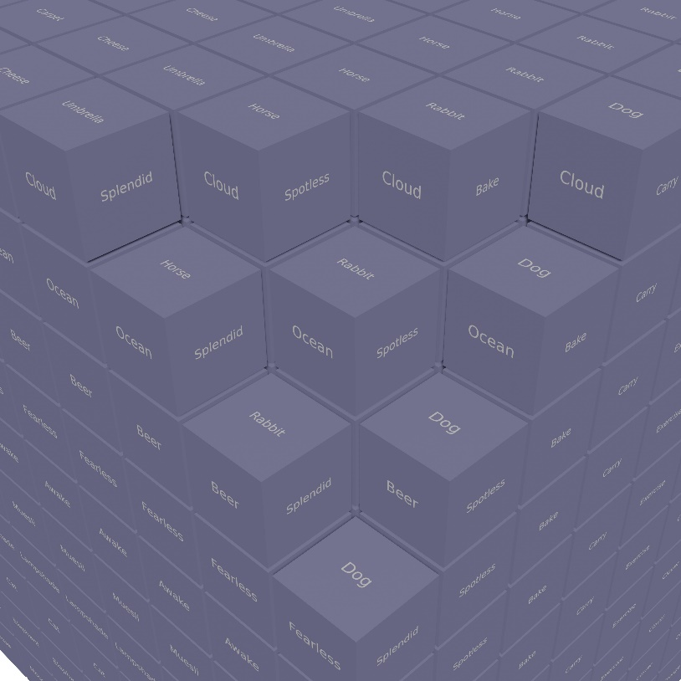
- Both - can you identify a three-words animal password using one animal from each row in your password?
The cube grid is be made up of 1000 cubes where each cube identifies a three-word password.
- If we were to restrict it to animals to find a three-word animal password how many cubes do you think we will need to look through?
- Ask the facilitator of the session to explain how many three-word animal passwords would be present.
Consider now a grid made up of any word from the dictionary three times to make a three-word password. This would result in a 171,476 by 171, 476 by 171, 476 cube grid, and this would produce a huge number 5,042,083,489,338,176 password possibilities!
If we were picking subsets of these words, such as animals, then the grid would not be so huge. This is why when we pick passwords we need to include a selection of at least three random words. This makes it harder for someone trying to access your online account to work out the password.

Exercise 6 – does your password fit the password rules of a website?
Sometimes websites want you to put in more than just characters. They often require:
- one special character which is from a selection of punctuation characters that are found on a computer keyboard:
!"#$%&'()*+,-./:;<=>?@[\]^_`{|}~
Sometimes a website will allow only a smaller selection of those above.
- one number: 0,1,2,3,4,5,6,7,8,9
- one upper case letter, for example, A, B, C, etc.
- one lower case letter, for example, a, b, c, etc.

Start with the following random three-word password:
cloudfearlessdog

Consider a website where the passwords rules require the use of AT LEAST ONE special character, AT LEAST ONE number, AT LEAST ONE upper case letter and AT LEAST ONE lower case letter in any password.
Complete the following where one example is provided:
Password | Is it valid? Answer Yes/No?
ocean.elephantcheese | No
ocean.elephantcheese2
Ocean.elephantcheese2
OceanelephantCheese2
OceanElephant.Cheese2
Ocean.Elephant.Cheese2
Ocean.Elephant.Cheese.25
!Ocean.Elephant.cheese.2

Produce one password yourselves based on “oceanelephantcheese” that meets the required password rules of the website.

We wanted to show you that there are many ways to create passwords, but a website will make it clear what rules there are and in our next activity we will identify a simple strategy that you can use all the time.

End of the activity – return to the group

Additional Resources
Here are links to the NCSC website with the government advice on creating a strong password and how to use passwords.
- Top tips for staying secure online
- Three random words or #thinkrandom
- The logic behind three random words
- Improve your password security

