Learner Guide
Lessons 2, 3, 4, 5

Introduction
This is a learner guide for the lessons within the Practice Using Passwords interactive training site produced by the University of Surrey. A learner can be anyone wanting to practice using the interactive training site.

Session Overview
Type of session: interactive using a computer/laptop/iPad/phone
Suggested length of session: 30-60 min session
Level: beginners
Background knowledge: a learner will need to have completed Lesson 1 of the training material or have an awareness of the importance of strong passwords
Physical Resources required: computer/laptop/iPad/smartphone
Resources provided in addition to this worksheet: online training site (hosted at https://uos-sccs.github.io/PUPS/ or by your organisation)

Learning Objectives
To help a learner practice registering and signing into a website using an email and a password, and using any additional checks that are typically added to security of these processes.
- Understand what information is needed by a typical website when registering to use a website
- Practice entering a password that is strong enough to use in a typical website
- Practice entering a security code as part of signing into a website
- Practice using visual checks as part of signing into a website

Keywords
password · login · obscure · re-attempt · security code · captcha

Lessons Overview
There are four lessons:
- Lesson 2 - this lesson will help you to choose an email and a strong password.
- Lesson 3 – this lesson will help you use the email and password that you have chosen to practice signing into (sign in) a website.
- Lesson 4 – this lesson will help you practice signing into a website where additional information is needed. Often websites ask you to enter an additional security code number, which is sent to your email. Websites want to do this in order to check that the person doing the sign in is the person that should be accessing the website and not someone else. This lesson will help you to recognise what emails containing these security code looks like. You will then use the security code to complete the signing into a website.
- Lesson 5 – this lesson will help you practice signing into a website where additional visual information is needed. Sometimes you are asked to carry out a little visual test as part of the signing into a website as websites want to check that the person doing the sign in is a person and not a robot .
For each lesson there is an accompanying demonstration of the lesson in action, see https://uos-sccs.github.io/PUPS/lessons

Setting up the Training Site
Before you can get started with the lessons within the training site, the training site guides you through a series of steps.
During the training you will be given a temporary email account. This email address is a simulation of a real email account. Is only for use during the lessons and is separate to your normal email account. It cannot be used to send or receive emails outside the training environment.
We do not use your real email account because we do not want to store any information about you.
Within the training site we have created a separate webpage to look like an email account where messages can be sent to you within the environment. This is needed in lesson 4 where we will learn that you sometimes need to look at an email in order to complete the signing in process on some websites.

Lesson 2 Registration
Timings | Topic | Activity | Notes
10 | Introduction | - Make sure you are sitting comfortably and have access to a computer  - Enter the following web-link into a browser: https://uos-sccs.github.io/PUPS/training/ or the link that your given by the organisation running the training with you | Make sure that as a learner you have tried Lesson 1 of the training material or be comfortable with knowing what passwords are before you begin this interactive training.
10 | Getting Started | - You will be asked to step through a few introductory web pages. Read the information on each of the pages | The pink and blue screens are the explanation screens.  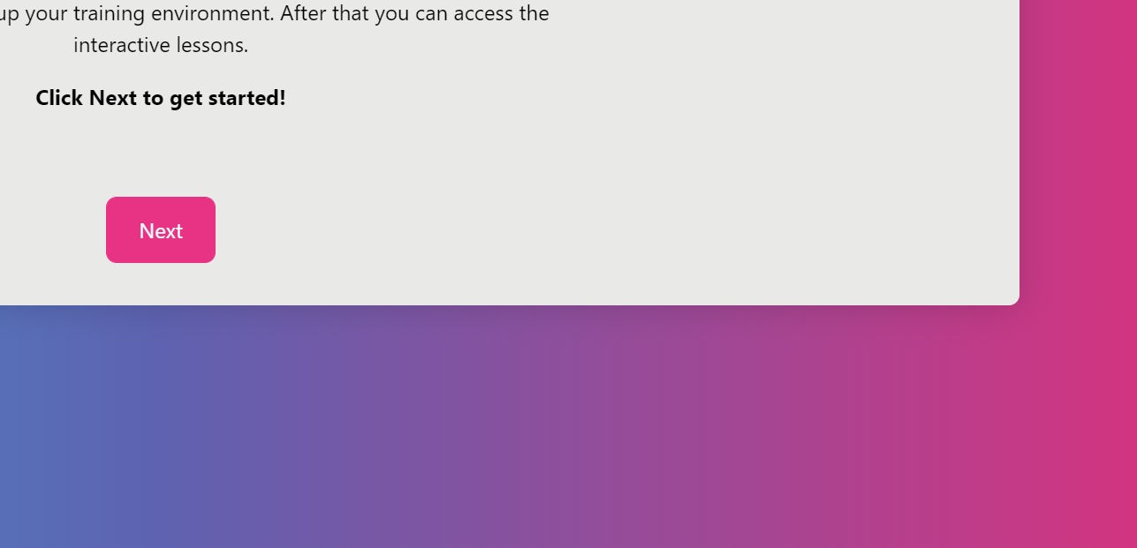
2 | Lesson 2 | - Click the start button to begin the lesson  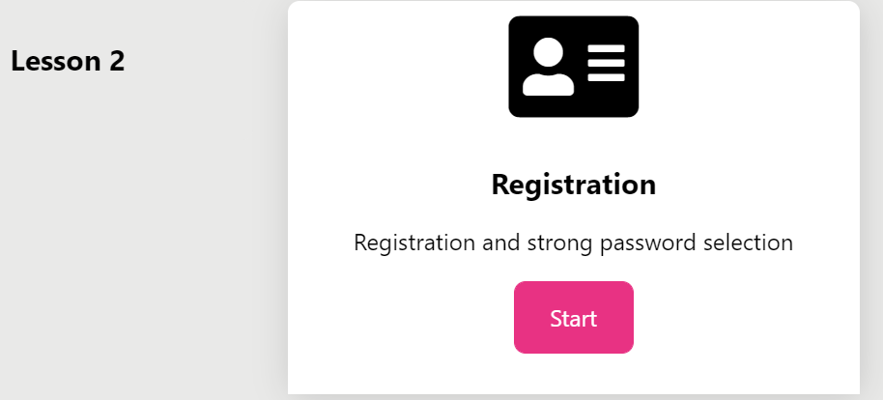
4 | Lesson 2 continued | - You will see a screen which looks like a normal webpage where you need to register for an email account. Enter your temporary email address and choose a good strong password and then press the Register button.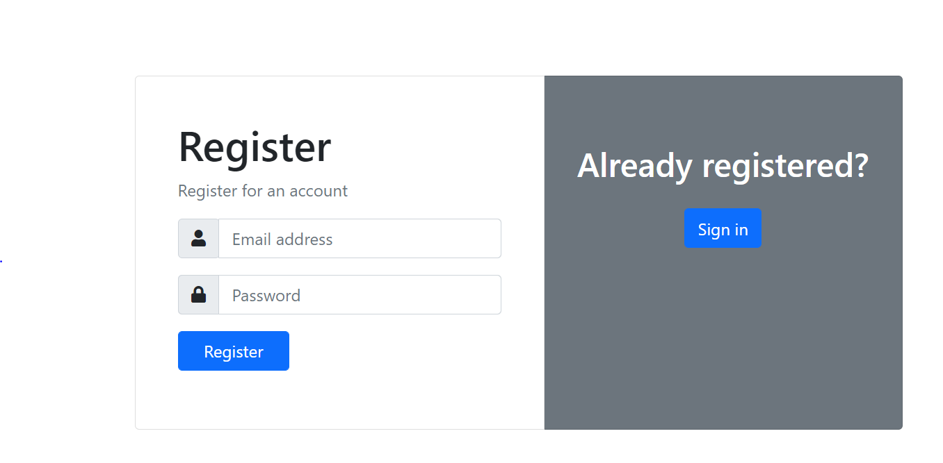 | The white and blue screens is the example practice website we are using and so they are in a different colour to the training pages. You could think of the blue and white pages as your online shopping or banking website for example.  You will see that the website also has a “Sign in” button. This is typical on a registration webpage because if you have already registered you will not want to register again. This is showing you that some images/boxes/writing on a web page are not all relevant to you at any one time.
2 | Lesson 2 continued | - After you press the Register button you will see a training summary of how strong your password was.  - Read the explanation.  - If the username was wrong or the password was weak you will be asked to try again but if everything was ok, then you have the option to go back to the training menu.  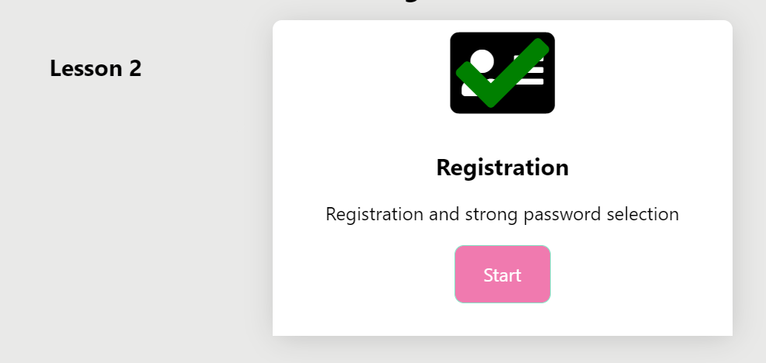  - You can see that you have finished it because the Registration page will have a tick and a green box. | Note the training site is checking for three different random words which is the NCSC recommendation. It is not checking for whether you meet a particular password strategy as we discussed in Lesson 1.  Technical note: we check the password by using a password analyser. It is trying to detect the presence of three different words. More often than not the analyser will provide a good summary but there are occasions when it may get it wrong. In such cases, the summary may not be what you expect.  For example, the words house and work could be one word too! So there could be some passwords that are made up of three random words the analyser can’t detect.
2 | End of Lesson | - This is the end of the lesson. Now that you have the training material open you can move seamlessly on to the next lesson.  - Reflect to see if you have met the learning outcomes of this lesson which was to “Understand what information is needed by a typical website when registering to use a website”.

Lesson 3 simple login
This is very similar to the previous Lesson 2. This time instead of registering you will be asked to try signing into the practice website. Normally, when you enter a password into a website you will not see it, such as it is obscured. Some websites provide an eye symbol that you can click so that you can display your password on the screen. You should not do this if you are in a public place where people could see your password by looking over your shoulder.
If you succeed in logging in, you will get a message with a green tick to say that you have been successful. Otherwise, you will be asked to try again.
If you sign in successfully on a real website, you will have access to your account and could start looking around the site. For example, you could start shopping or looking at your bank account details.

Lesson 4 simple login with email check
Lesson 4 builds on Lesson by adding one additional step after you enter the username and password. This is where the training account is needed. Lesson 4 starts off like lesson 3 but has the following new steps that you need to complete the exercise.
Topic | Activity | Notes
Lesson 4 – accessing your email account | When you see  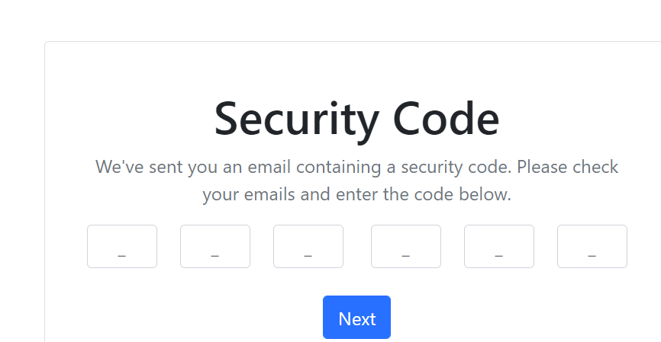  you will need to go to the training email account. To open the training email account, press the pink question mark in the top left  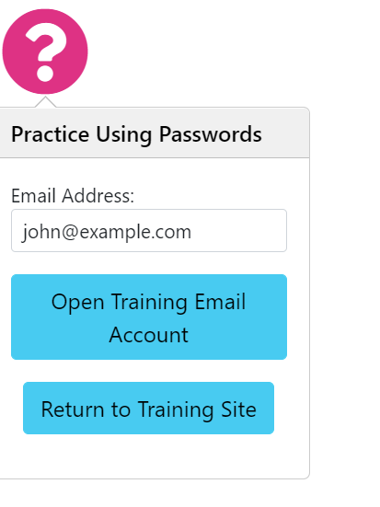
Lesson 4 – looking for a code in your email account | Then you will see a new tab appear in the web browser. Open up the message in the inbox to find the code. Then make a copy of the code by either pressing keys CTRL and C or by remembering it in your head. 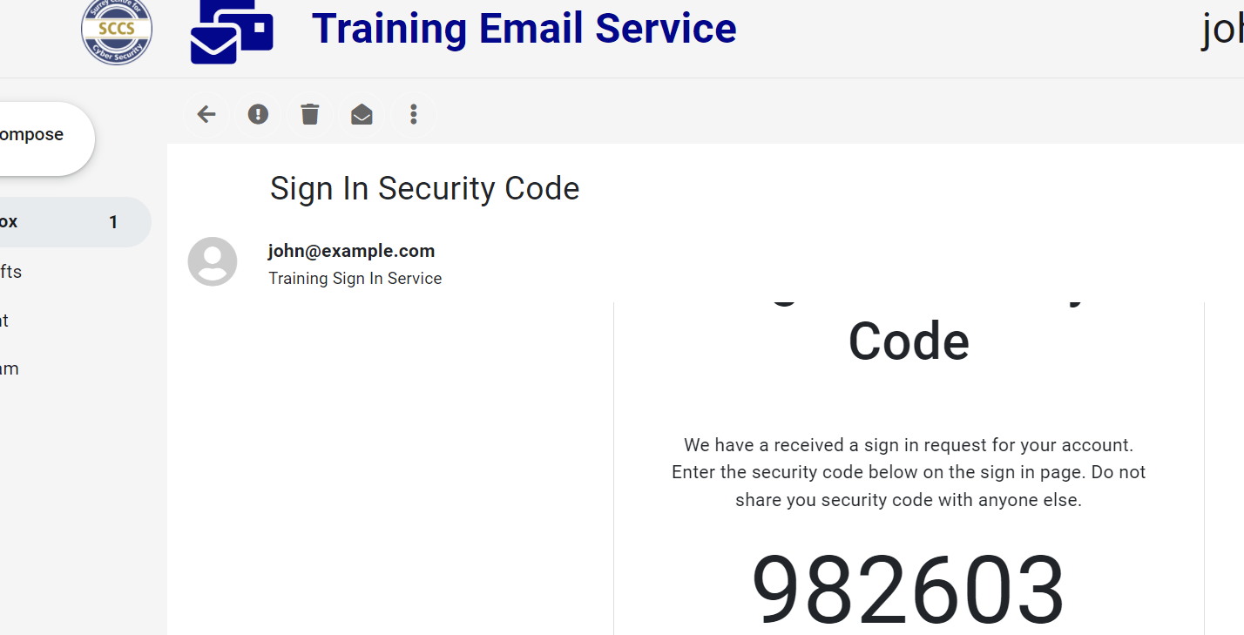 | Don’t worry if you get it wrong you will be prompted to try again.
Lesson 4 – entering the code into the webpage | Next, you need to go back to the training page. You can do this by finding the tab at the top of the browser or by clicking on the pink question mark to take you back.  Once back you need to enter the code by either  - Clicking into the first box and typing CTRL V or  - Entering the numbers one at a time into the box  Then you can press the “Next” button.

Lesson 5 simple login with visual check
Lesson 5 also builds on Lesson 3. It adds one additional step after you enter the username and password. The extra step is a visual test to check that you are not a robot. These tests are called CAPTCHA. It first asks you to tick a box. Then a grid of 9 images appears and you are prompted to click on particular images, for example all the buses:


In the training site, we have included images of buses, hydrants, roads and taxis and which ones you will be asked to choose will be determined at random.

Completing the training
You can revisit the lessons as many times as you like. They don’t all have to be completed all at once. You could bookmark the page and come back to it.
When you have finished you need to click “Finished Training” so that your temporary email account is deleted from the machine that you are using.

